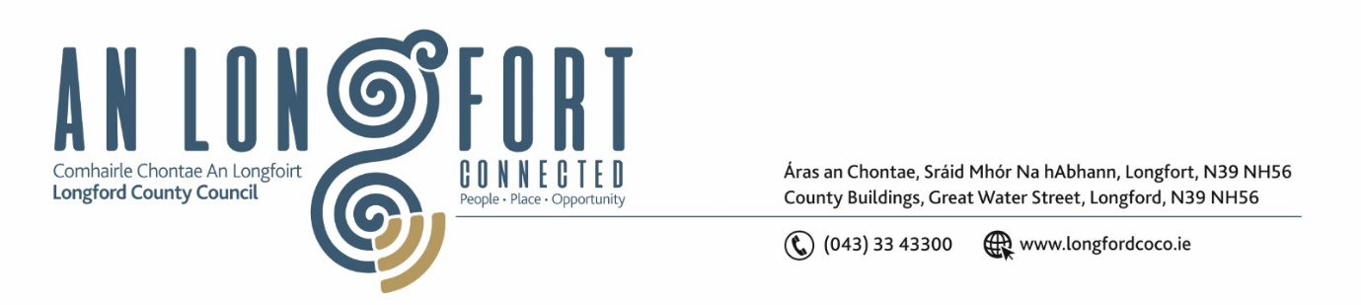

***LONGFORD MUNICIPAL DISTRICT***

***Please note meeting will be held via Microsoft Teams***

**17 February 2022.**

**To: Each Member of Longford Municipal District.**

**Dear Member,**

You are requested to attend the Meeting of Longford Municipal District to be held

**via Microsoft Teams** on **Wednesday 23 February 2022 at 3.30pm** to transact business, as set out on the Agenda hereunder.

**Yours sincerely**,

Ann Marie Mc Keon

_______________

**Ann Marie Mc Keon**

**Meetings Administrator.**

**AGENDA**

Prayer before meeting.

**1.** Confirmation of Minutes -

1. Longford Municipal District Meeting held on Wednesday 26 January 2022– copy enclosed.
2. Longford Municipal District Committee Meeting held on Wednesday 8 December 2021 – copy enclosed.

**2.** Matters arising from Minutes.

**3.** Declaration of Interest by Members.

**4.** Management Report - enclosed.

**5**. Proposed Projects/Expression of interests.

**6.** Consideration of application for funding under the 2022 Community Grant Support Scheme - list enclosed.

**7.** Update on Project in Longford Town.

**8.** Taking in charge “Leader Park” – enclosed.

**9.** Submission of Notice of Motions for agenda**.**

**10.** Notices of Motions, submitted by Councillors, as listed hereunder –

**Councillor Gerry Warnock**

In anticipation of the commencement of the Royal Canal Spur Gateway Project later this year and the future development of the recently acquired Longford Greyhound Track Site, I am proposing that we prepare a plan for the extension of the CCTV Network to take in the proposed public space at the Rear of the Market Square (Old Harbour Site); the beginning of the existing Longford Canal Walk on the green area directly past the railway bridge (Harbour View) between Farranyoogan Estate and Canal Bank Estate; approval in principal for units at Longford Greyhound Track to be incorporated into the agreed development plan for that site. These areas have a history of antisocial activity (Dumping, Public Drinking & Drug Dealing) and the placement of these cameras would provide peace of mind for local residents and for all who use the amenity for sport and recreation. I am proposing that this plan be prepared and forwarded to the CCTV Monitoring Committee so they can make a recommendation for the consideration of the elected members, so we can have this ready to go before construction phase of the Canal Spur Gateway Project.

**Councillor Martin Monaghan**

“I am call on the Longford Municipal District to seek funding to install a footpath on the Demesne Lane. This area of the town has been growing steadily over the last few years, with added housing and a sports facility namely Longford Tennis Club.”

**Councillor Gerry Hagan**

“I call on Longford Municipal District to carry out a low-cost safety scheme along the Ballinalee Longford road from the junction of the Kelleter lane towards Longford”.